**Day 12 Assignment - 16/12/2023 - Vamsi Viswanadham**

Worked on the Below Concepts.

* **Lambda Expressions**

In Python, an anonymous function means that a function is without a name. As we already know the def keyword is used to define the normal functions and the lambda keyword is used to create anonymous functions.

Here is an example of the lambda function: Here we have just created a lambda function that takes x as an input and multiply itself three times and store that in the cube_v2 variable.

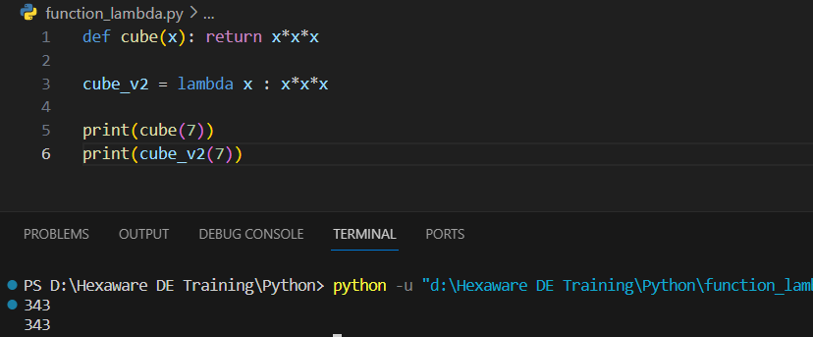

* **Date class:**

The date class is a part of the datetime module in Python and is used for manipulating dates (year, month, day). It provides various methods and properties to work with dates.

Here's a Python script that demonstrates several key methods and properties of the date class:

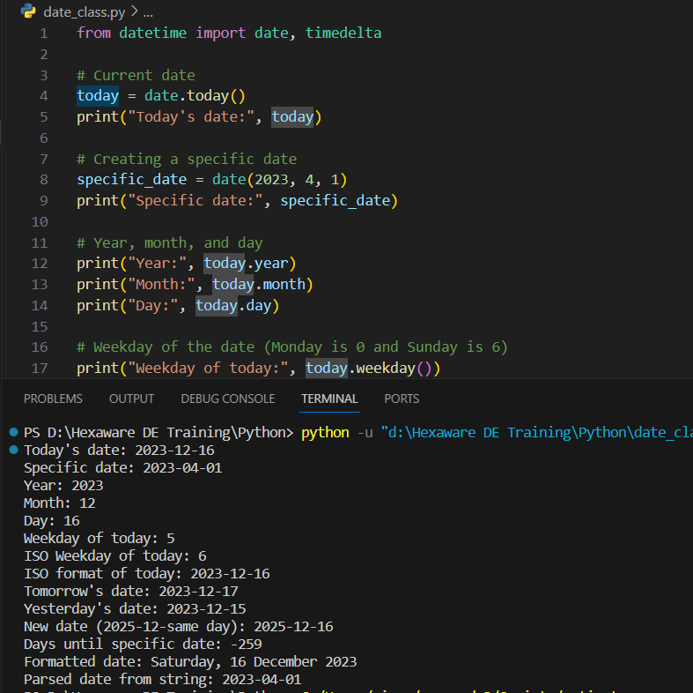

* Calendar module:

The calendar module in Python provides a set of functions to output calendars like the Unix cal program, and provides additional useful functions related to the calendar. Functions in this module do not deal with dates and times directly, but they are helpful for manipulating and formatting calendars.

Here's a Python script that demonstrates several key methods from the calendar module:

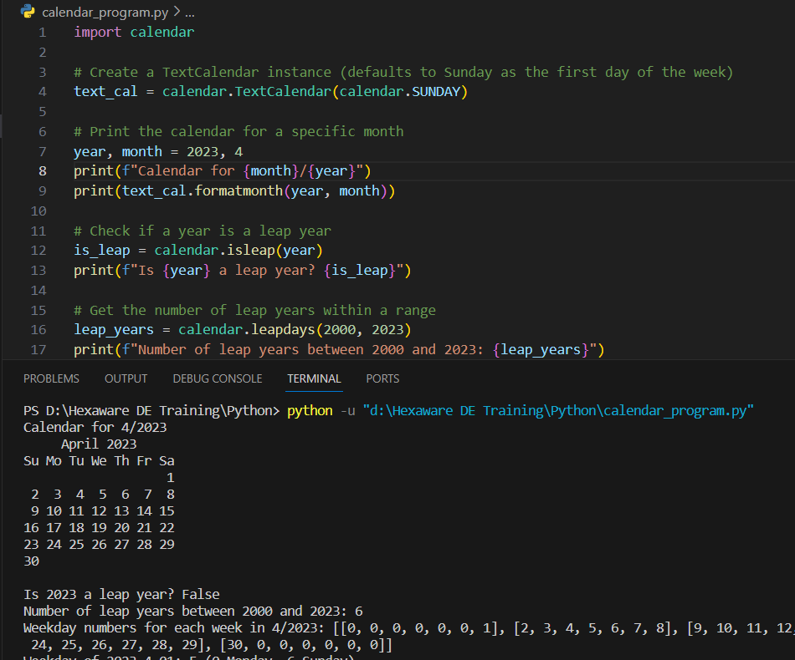

* Time class:

The time module in Python provides various time-related functions. Unlike the datetime module, which deals with dates and times together, the time module mainly focuses on time as measured in seconds since the epoch (January 1, 1970, 00:00:00 UTC).

Here's a Python script that demonstrates several key methods from the time module:

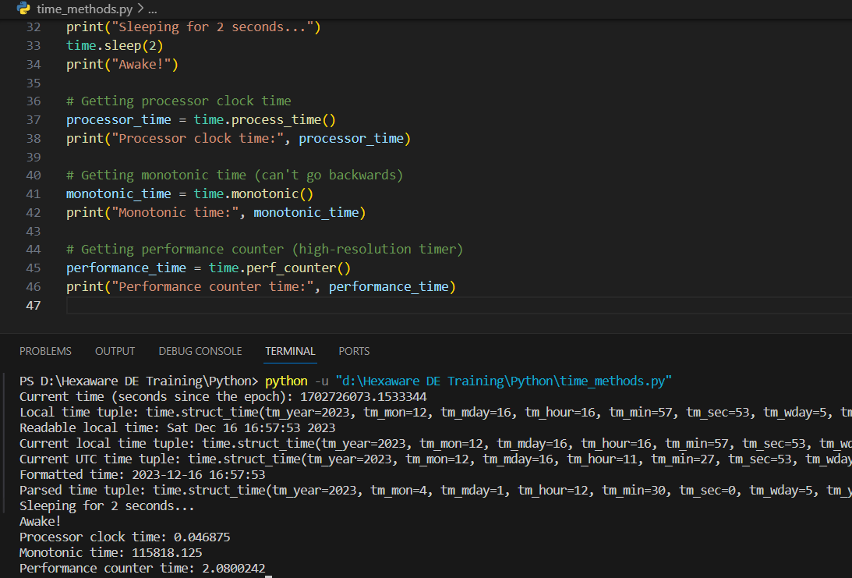

* Datetime module:

The datetime module is quite extensive, as this module provides numerous classes and functions for manipulating dates and times. The datetime module in Python includes several classes like date, time, datetime, timedelta, and timezone, each with its own set of methods.

Here is program output:

